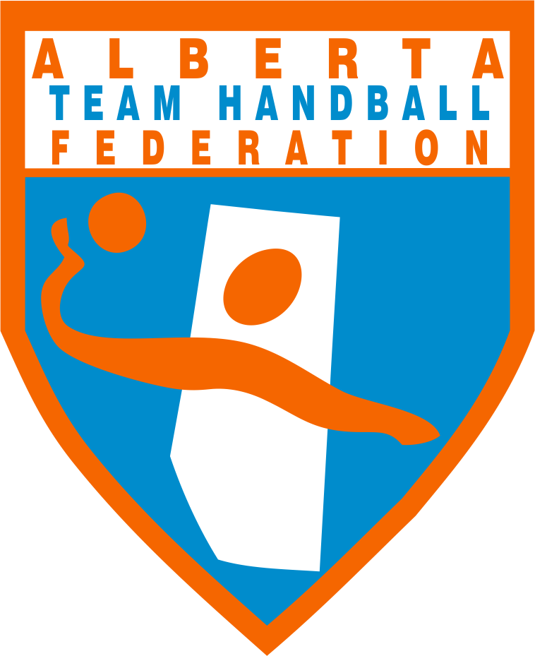 | Alberta Team Handball Federation - Job Posting

Position:  Travel Dates:  Position Reports to:  Travel Supervisor (s): | Team Manager - Volunteer Position (Temporary)  For: 2022-23 tournaments  January - May  ATHF Executive Director - Carl Barton  U21 coaches - Khalil El Haddaoui and David Gingles

Summary: Do you enjoy helping team handball players enjoy the sport of handball? Do you work well with others? Do you have a keen eye for detail? Do you thrive on multitasking and enjoy a team environment? Are you able to follow instructions and ensure the safety of others? Have you successfully volunteered for a sports organization before? If your answer is a resounding yes, join us as a Volunteer Team Manager for Alberta Team Handball Federation.
The Alberta Team Handball Federation works hard to provide a safe and inclusive environment for Alberta Team Handball Players, and continues to make a real difference in our communities. In this role, you will be responsible for a variety of administrative duties related to traveling overseas with provincial handball players and coaches.
Key duties included: Coordinating with the ATHF Executive Director and Team Coaches to ensure all travel documents are in order prior to traveling overseas. Ensure the players and parents are advised of travel dates and arrival time at the airport. Ensure all the appropriate travel documents and travel items are communicated to the players and parents prior to departure. Assist the travel coaches with team tasks prior, during and for a successful arrival back in Canada. Taking photos of the team that ATHF can use on social media and other marketing materials. Providing an “After-Travel Report” to the Executive Director.

As the ideal candidate, you excel in working together with the ATHF Executive Director, Coaches, and Players. An ideal candidate will also represent ATHF in a positive and professional way during the team’s travel.

Qualifications:
- Prior volunteer experience with a non-profit sports organization. Ideally with more than one sports organization
- Held a leadership role
- Time-management skills
- Problem-solving capability
- Decision-making skills
- Communication skills
- Mentorship
- Ability to work under pressure
Team-oriented mindset
- Strategic planning abilities
- Abilities to grow and develop as a volunteer team manager
- Photography
Note:
- Equivalencies may be considered for those with related work experience
- Satisfactory background screening is required for this position which includes a Criminal Record Check/Police Information Check and Vulnerable Sector Check

What do you need to bring to this position?
- Excellent customer service orientation
- Effective written and verbal communication abilities
- Strong organizational and time management skills
- Attention to detail
- Initiative
- Ability to excel in a team-oriented environment
- Ability to work independently to complete assignments

Travel: Hours of work
Be available in the early mornings to help organize daily activities. Assist the coaches with tasks related to the players, the tournament and travel requirements. In the event a player requires medical attention, accompany the players to the appropriate medical facility and stay with the player until they return with the team.

Benefits: The trip airfare and accommodations are paid for by ATHF.

Posting Date: Monday, December 12, 2022
Closing Date: Friday, January 6, 2023
Apply at: info@albertateamhandball.com

